**Modul 5**

Nama : Andrias Sigid W.R

NIM : L200144010

Percobaan 1

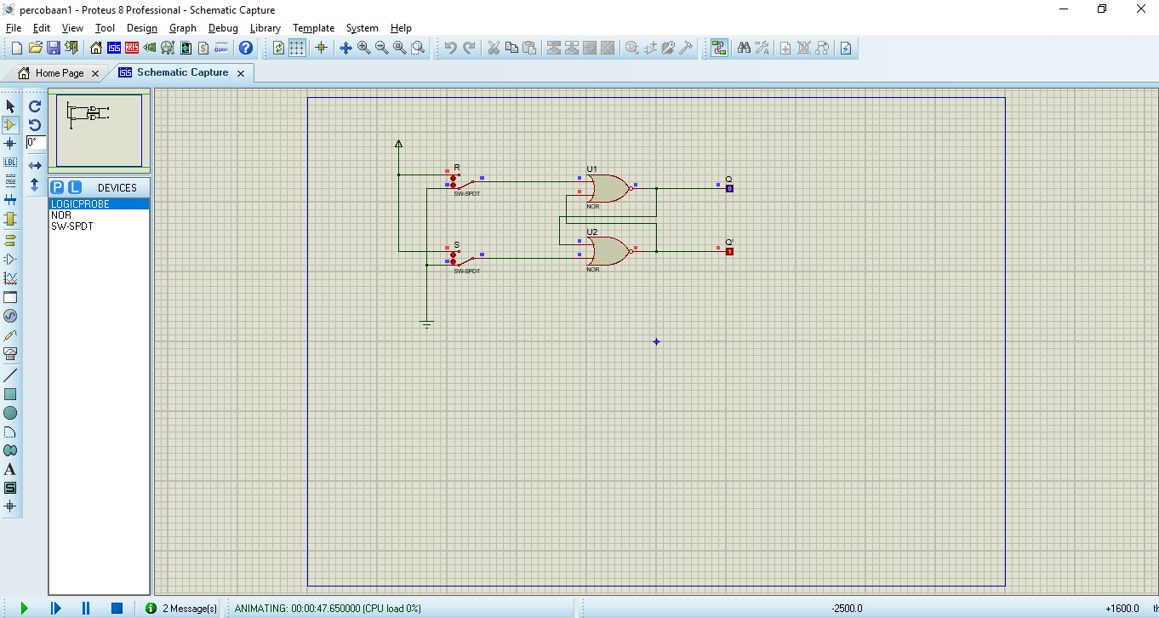

2.

|  |  |  |  |  |
| --- | --- | --- | --- | --- |
|  | S (Set) | R (Reset) | Output | |
| Q | Q’ |
| 1 | 0 | 1 | 0 | 1 |
| 2 | 0 | 0 | 0 | 1 |
| 3 | 1 | 0 | 1 | 0 |
| 4 | 0 | 0 | 1 | 0 |
| 5 | 1 | 1 | 0 | 0 |

3.a. jika kondisi S + R = 0? Terjadi kondisi Q flop dan Q’ flip

3.b. S = R = 1 tidak di perbolehkan,dapat terjadi kondisi Flop Flop

Percobaan 2

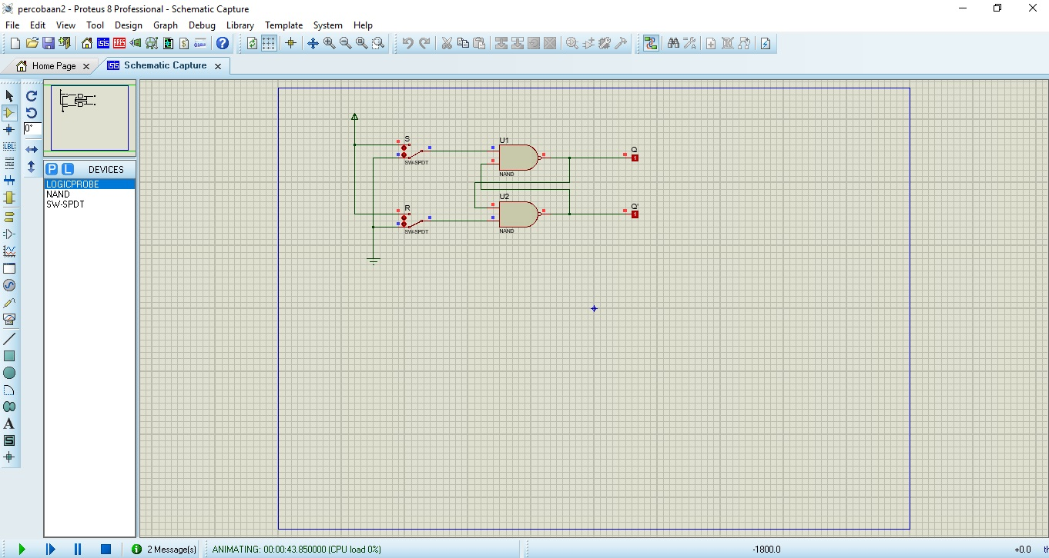

3. a. Jika diberikan kondisi S = R = 1,Terjadi output menyala pada Q dan Q’ mati

3. b. S = R = 0 tidak diperbolehkan ? akan terjadi kondisi flip-flop

Percobaan 3

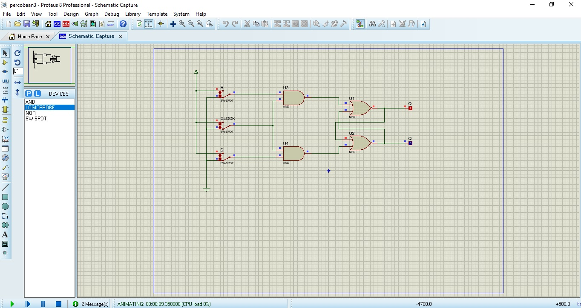

2.

|  |  |  |  |  |  |
| --- | --- | --- | --- | --- | --- |
|  | S (Set) | R (Reset) | CLOCK | Output | |
| Q | Q’ |
| 1 | 0 | 0 | 0 | 1 | 0 |
| 2 | 0 | 0 | 1 | 1 | 0 |
| 3 | 0 | 1 | 0 | 0 | 1 |
| 4 | 0 | 1 | 1 | 0 | 1 |
| 5 | 1 | 0 | 0 | 1 | 0 |
| 6 | 1 | 0 | 1 | 1 | 0 |
| 7 | 1 | 1 | 0 | 0 | 1 |
| 8 | 1 | 1 | 1 | 0 | 1 |

3. Apa yang terjadi jika kondisi S = R = 1 dan clock berubah dari 1 ke 0? Terjadi output Q flop dan flip pada Q’

4.Karnaugh Map

|  |  |  |  |  |  |
| --- | --- | --- | --- | --- | --- |
|  | | AB | | | |
| 00 | 01 | 11 | 10 |
| C | 0 | 0 | 1 | 1 | 0 |
| 1 | 1 | 1 | 1 | 1 |

Percobaan 4. Flip Flop D

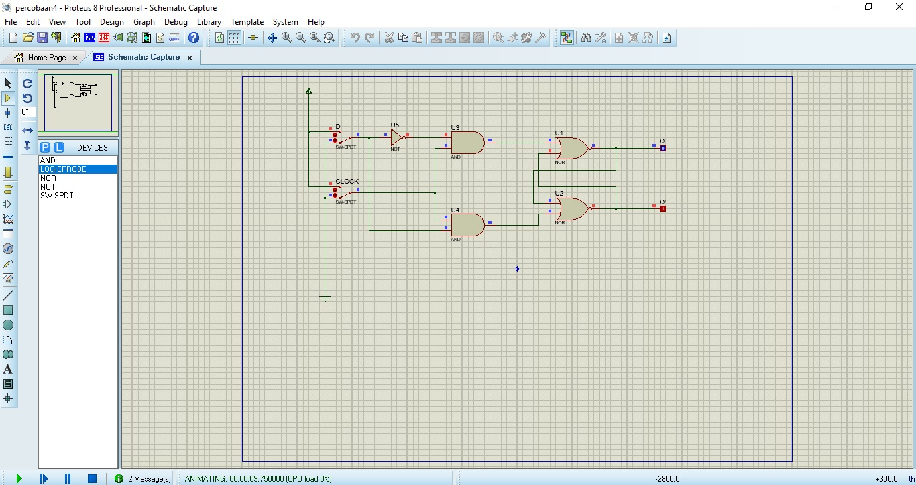

2.

|  |  |  |  |  |
| --- | --- | --- | --- | --- |
|  | D | CLOCK | Output | |
| Q | Q’ |
| 1 | 0 | 0 | 0 | 1 |
| 2 | 0 | 1 | 0 | 1 |
| 3 | 1 | 0 | 1 | 0 |
| 4 | 1 | 1 | 1 | 0 |
| 5 | 0 | 0 | 0 | 1 |
| 6 | 0 | 1 | 0 | 1 |
| 7 | 1 | 0 | 1 | 0 |
| 8 | 1 | 1 | 1 | 0 |

3. Bagaimana Flip-Flop bekerja ? Jika D dalam kondisi 1 maka output Q = 1 dan Q’ = 0, jika D kondisi 0 maka output Q = 0 dan Q’ = 1

Percobaan 5. Flip-Flop JK

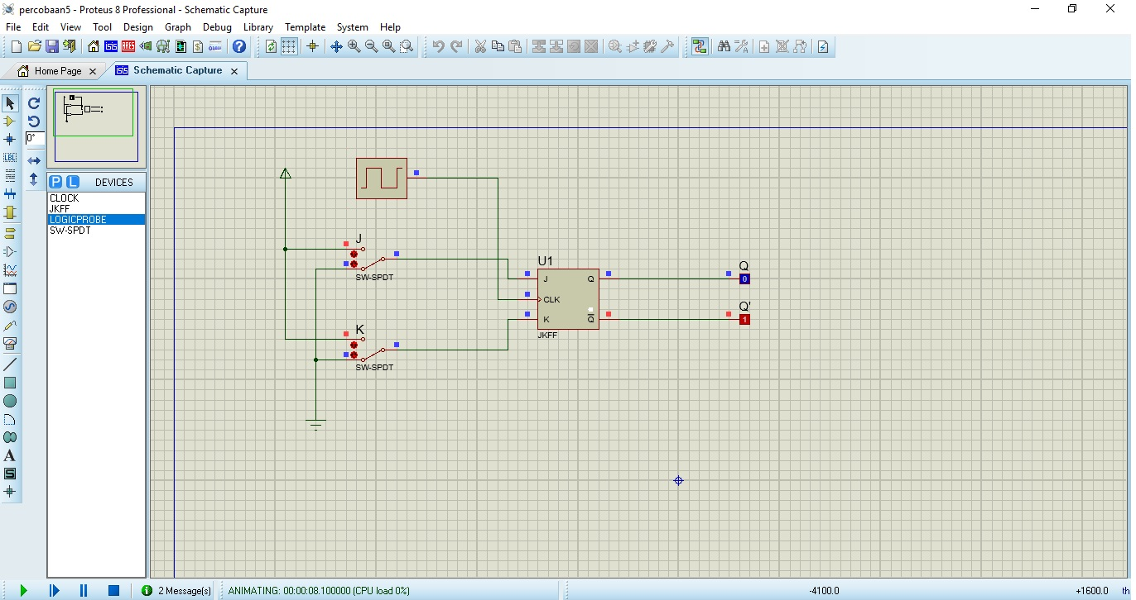

2.

|  |  |  |  |  |
| --- | --- | --- | --- | --- |
|  | D | CLOCK | Output | |
| Q | Q’ |
| 1 | 0 | 0 | 0 | 1 |
| 2 | 0 | 1 | 0 | 1 |
| 3 | 1 | 0 | 0 | 1 |
| 4 | 1 | 1 | 0 | 1 |
| 5 | 0 | 0 | 1 | 0 |
| 6 | 0 | 1 | 1 | 0 |
| 7 | 1 | 0 | 0 | 1 |
| 8 | 1 | 1 | 1 | 0 |

3. a. Apa yag terjadi jika J = K = 0, dan clock rise up (change from 0 to 1) ? terjadi output Q dan Q’ Flop Flip

3. b. Apa yang terjadi jika J = K = 1, dan clock rise up ? Terjadi output flip flop jika clock mati, terjadi flop flip jika clock hidup

4. bagaimana flip flop JK bekerja ? apabila J = 0 dan K = 1 master direset melalui sisi naik pulsa clock , output Q’ membuat slave terseret